Bachelor Thesis
Submitted in Partial Fulfillment of the Requirements
for the Degree of Bachelor of Science in “Gesundheitswissenschaft”
at the TUM School of Medicine and Health, Department Health and Sport Sciences
at the Technical University of Munich

English Title

German Title

Submitted by
Max Mustermann

Referee
Prof. Dr. Michael Laxy

Munich, 5th of November 2028

Table of Contents
List of Tables 3
List of Figures 4
List of Abbreviations 5
Abstract 6
1 Paragraph 7
1.1 Subparagraph 1 7
1.1.1 Subsubparagraph 1 7
References 8
Appendix 9

List of Tables
Table 1: Summary Statistics 7

List of Figures
Figure 1: Plot 7

List of Abbreviations
BMI Body mass index
DALY Disability-adjusted life year
IV Instrumental variable

Abstract
Include the Abstract (250-300 Words)

Number of Words in the Abstract: XXX
Number of Words in the Main Text: XXX
Number of Tables and Figures in the Main Text: XXX

Paragraph

Subparagraph

Subsubparagraph
It is well established in the literature that Z has an effect on Y (Alberti et al., 2007).
According to Alberti et al. (2007), X has an effect on Y.
The authors of a recent study claim that “X has a significant effect on Y after controlling for Z” (Alberti et al. 2007, p.XY).
Figure 1 illustrates the described relationship.
Table 1 depicts the descriptive statistics for our sample.
What about footnotes

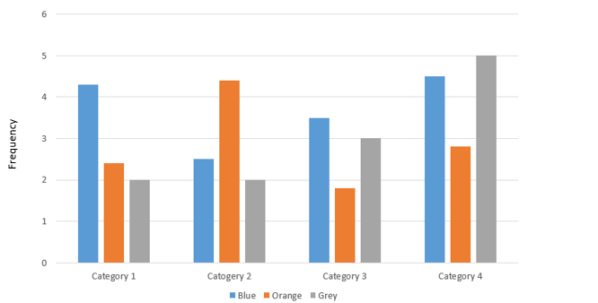
Notes: Information that makes the figure self-explanatory.
Figure 1: Plot

Table 1: Overview of something
 | Column 1 | Column 2
Row 1 | … | …
Row 2 | … | …
Notes: Information that makes the table self-explanatory

References
Alberti, K. G. M. M., P. Zimmet and J. Shaw (2007). International Diabetes Federation: a consensus on Type 2 diabetes prevention. Diabetic Medicine 24(5): 451-463.

Appendix

Declaration of Authorship

I hereby declare that I have written this submitted thesis myself, independently and have used no other than the specified sources and resources. I agree that this work may be assessed using plagiarism detection software and am fully aware of the consequences of plagiarism or violation of good scientific practices.
This thesis was not previously presented to another examination board and has not been published.

Munich, …………….. …………………………………
(Signature)

Use footnotes sparingly.

